|  |  |  |  |  |  |  |  |  |  |  |  |
| --- | --- | --- | --- | --- | --- | --- | --- | --- | --- | --- | --- |
| 管 | 1 | 2 | 3 | 4 | 5 | 6 | 7 | 8 | 9 | 10 | 11 |
| 时间 | 3 | 5 | 7 | 10 | 12 | 15 | 20 | 25 | 30 | 40 | 50 |
| OD_680 | 0.032 | 0.061 | 0.084 | 0.149 | 0.147 | 0.190 | 0.247 | 0.301 | 0.353 | 0.474 | 0.579 |

|  |  |  |  |  |  |  |  |  |
| --- | --- | --- | --- | --- | --- | --- | --- | --- |
| 管 | 1 | 2 | 3 | 4 | 5 | 6 | 7 | 8 |
| OD1 | 0.099 | 0.187 | 0.242 | 0.350 | 0.467 | 0.510 | 0.675 | 0.774 |
| OD2 | 0.104 | 0.188 | 0.250 | 0.407 | 0.495 | 0.543 | 0.677 | 0.784 |
| 酚含量 | 0.04 | 0.08 | 0.12 | 0.16 | 0.20 | 0.24 | 0.28 | 0.32 |
| OD_680 | 0.102 | 0.188 | 0.246 | 0.379 | 0.481 | 0.527 | 0.676 | 0.779 |

|  |  |  |  |  |  |  |  |
| --- | --- | --- | --- | --- | --- | --- | --- |
| 管 | 1 | 2 | 3 | 4 | 5 | 6 | 7 |
| OD1 | 0.012 | 0.020 | 0.038 | 0.054 | 0.081 | 0.120 | 0.509 |
| OD2 | 0.003 | 0.018 | 0.032 | 0.063 | 0.097 | 0.130 | 0.495 |
| OD_680 | 0.008 | 0.019 | 0.035 | 0.059 | 0.089 | 0.125 | 0.502 |
| [S] | 0.00868 | 0.01343 | 0.02005 | 0.02976 | 0.04237 | 0.05725 | 0.21308 |
| v_0 | 0.00050 | 0.00127 | 0.00233 | 0.00390 | 0.00593 | 0.00833 | 0.03347 |
| 1/[S] | 115.205 | 74.4400 | 49.8825 | 33.6014 | 23.6029 | 17.4679 | 4.69311 |
| 1/v_0 | 2000.00 | 789.474 | 428.571 | 256.410 | 168.539 | 120.000 | 29.8805 |

Vmax=1/249.25=0.00401

Km=17.365*Vmax=0.06967

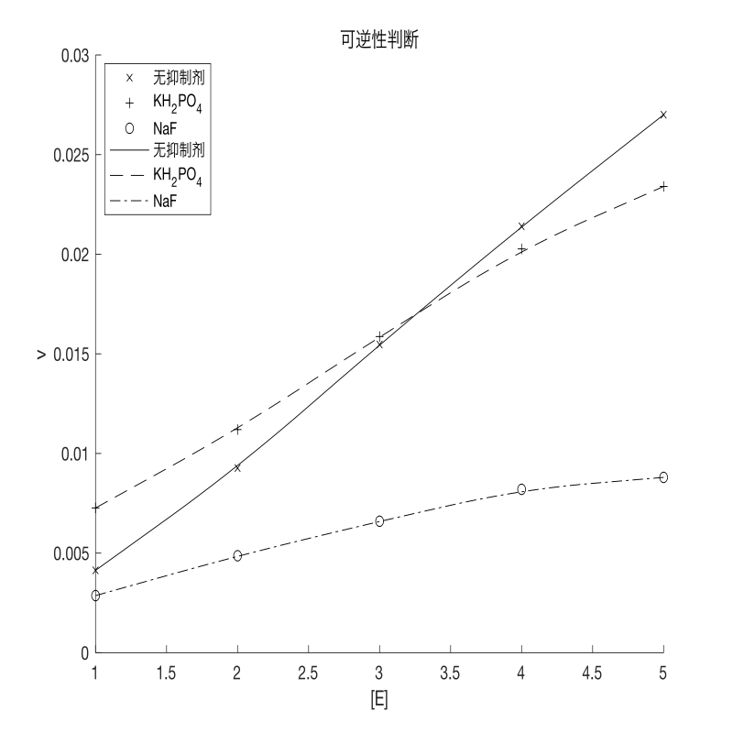

|  |  |  |  |  |  |  |
| --- | --- | --- | --- | --- | --- | --- |
|  | 管 | 1 | 2 | 3 | 4 | 5 |
| [E] | 相对浓度 | 1.000 | 2.000 | 3.000 | 4.000 | 5.000 |
| OD_680 | 无 | 0.062 | 0.139 | 0.232 | 0.321 | 0.405 |
| KH2PO4 | 0.109 | 0.168 | 0.238 | 0.304 | 0.351 |
| NaF | 0.043 | 0.073 | 0.099 | 0.123 | 0.132 |
| v | 无 | 4.133E-03 | 9.267E-03 | 1.547E-02 | 2.140E-02 | 2.700E-02 |
| KH2PO4 | 7.267E-03 | 1.120E-02 | 1.587E-02 | 2.027E-02 | 2.340E-02 |
| NaF | 2.867E-03 | 4.867E-03 | 6.600E-03 | 8.200E-03 | 8.800E-03 |

KH2PO4为可逆抑制剂

NaF为可逆抑制剂

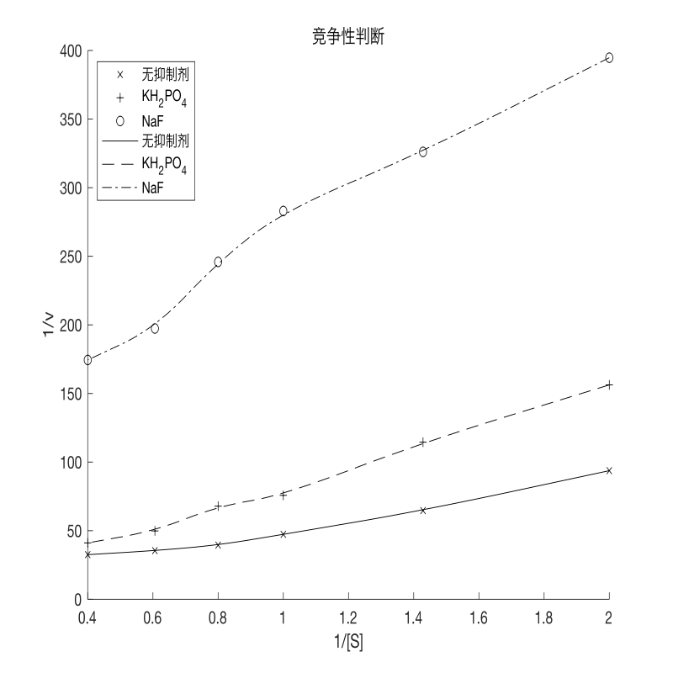

|  |  |  |  |  |  |  |  |
| --- | --- | --- | --- | --- | --- | --- | --- |
|  | 管 | 1 | 2 | 3 | 4 | 5 | 6 |
| [S] | 浓度 | 0.50 | 0.70 | 1.00 | 1.25 | 1.65 | 2.50 |
| OD_680 | 无 | 0.160 | 0.232 | 0.317 | 0.380 | 0.423 | 0.461 |
| KH2PO4 | 0.096 | 0.131 | 0.198 | 0.221 | 0.301 | 0.365 |
| NaF | 0.038 | 0.046 | 0.053 | 0.061 | 0.076 | 0.086 |
| v | 无 | 1.067E-02 | 1.547E-02 | 2.113E-02 | 2.533E-02 | 2.820E-02 | 3.073E-02 |
| KH2PO4 | 6.400E-03 | 8.733E-03 | 1.320E-02 | 1.473E-02 | 2.007E-02 | 2.433E-02 |
| NaF | 2.533E-03 | 3.067E-03 | 3.533E-03 | 4.067E-03 | 5.067E-03 | 5.733E-03 |
|  | 1/[S] | 2.000 | 1.429 | 1.000 | 0.800 | 0.606 | 0.400 |
| 1/v | 无 | 93.750 | 64.655 | 47.319 | 39.474 | 35.461 | 32.538 |
| KH2PO4 | 156.250 | 114.504 | 75.758 | 67.873 | 49.834 | 41.096 |
| NaF | 394.737 | 326.087 | 283.019 | 245.902 | 197.368 | 174.419 |

KH2PO4为竞争性抑制

NaF为非竞争性抑制